UTK Faculty Salary Survey Comparison, Academic Year 2016-2017

Prepared for the UTK Faculty Senate, Budget and Planning Committee by K. Baker and L.J. Gross, March 2018

This report uses data compiled and provided by the UTK Office of Institutional Research and Assessment (OIRA). The Committee thanks Donald Cunningham for his assistance with answering our questions. The Appendix provides the comparisons to various peer groups.

The data/columns received by the committee include:

- College/Department/Rank (eg. Haslam College of Business/Economics/Full Professor)
- UTK Average, Minimum and Maximum Salaries by rank, and all ranks; number of positions
- Average, Minimum and Maximum Salaries by rank for ‘Research 1: Doctoral-Highest Research’ Peer Institutions
- Cost to increase Average UTK Salaries to match Average R1 Salary, by rank
- Ratio of UTK Average Salary to Average R1 Salary, by rank
- Average, Minimum and Maximum Salaries by rank for Comparable Peer Institutions
- Cost to increase Average UTK Salary to match Average Comparable Peer Salary, by rank
- Ratio of UTK Average Salary to Average Comparable Peer Salary, by rank
- Average, Minimum and Maximum Salaries, by rank, for Aspirational Peer Institutions
- Cost to increase Average UTK Salary to match Average Aspirational Peer Salary, by rank
- Ratio of UTK Average Salary to Average Aspirational Peer Salary, by rank

The data provided also includes the numbers of faculty in each rank/department at UT and the total faculty in the data from the institutions included in the comparison groups.

Those included in the dataset are:
- All full-time tenure track faculty with an instructional appointment from UTK, UTSI and UTIA
- Department heads and those with job titles such as Professor and Associate Dean
- Job titles starting with faculty titles are considered to be primarily instructional (and are included)
- Clinical faculty

Those not included in the dataset are:
- Non-tenure-track faculty
- Library faculty
- Veterinary Medicine faculty
- Administrative Positions
- Research faculty without instructional appointments

All salaries are calculated on a nine-month basis, and include longevity pay and administrative supplements for those individuals who have them. Salaries do not include summer pay from externally-funded projects (e.g. summer funding from grants).

Note that the calculations include the funding needed to raise every unit/rank to average or above. When aggregated at the College of University level, this can lead to anomalies in that some College’s average salaries may be well above the average of a comparison group at all ranks, but the report still shows that funds are needed to increase that College to the average of the comparison group. This is because funds are still needed to raise every unit/rank within the College to the respective averages of the comparison group. This approach does not account for any variance in average salaries across units/ranks relative to the peer group average that may exist at institutions in the comparison groups.

Notes and Caveats particular to this report:

- There has been a significant change in the comparison groups
- Previous data sets provided to the committee by OIRA compared UTK salaries against 3 Peer Groups: Research Universities labeled as Very High (63 schools with 64,725 total faculty); Top 25 Public Universities (22 schools with 29,169 total faculty); and THEC (16 schools with 14,259 total faculty)

- This data set also compares UTK salaries against 3 Peer Groups: Research 1: Doctoral (presumably the same 63 schools, with 63,835 total faculty); Comparable Peers (11 schools with 10,081 total faculty) and Aspirational Peers (6 schools with 8,875 total faculty).

- The committee asked OIRA about this change, and were given this response: ‘The Board of Trustees asked all UT institutions recently to create new, shorter peer lists. A detailed analysis was done on each campus. OIRA was directed to only use the new UTK peers for all comparison studies, and they were also used for the Vol Vision Strategic Plan refresh.’

- This change in comparison groups significantly reduced the size and robustness of the Peer Groups directed to be used by OIRA
- In previous data sets, UTK was compared against 3 different targets, with school sizes of 63, 22 and 16
- In this dataset, UTK is compared against 3 different peer targets, with schools sizes of 63, 11 and 6
- It is our position that the small sample size of the 11 (Comparable) and 6 (Aspirational) Peer targets may skew the analysis as the low sample sizes of institutions and their associated total faculty could bias the findings in a variety of ways. For example:
  - In the College of Engineering, there is no salary data for comparison against the UTK Nuclear Engineering department versus either the Comparable or Aspirational Peer Groups
  - In the College of Communication and Information, there is no salary data for comparison against the UTK Advertising and Public Relations department versus the Aspirational Group
  - For total faculty, R1 provides a dataset of 63,835 faculty, while Comparable provides 10,081 and Aspirational provides 8,875
  - For example, in the Classics Department, the R1 Group includes 260 faculty for comparison, while the Peer Group includes only 18 and Aspirational Group includes 41.
  - For example, in the Information Sciences, the Aspirational Peer group includes only 44 faculty for comparison, the Comparable Peer group includes only 53, while the R1 group includes 451.
  - Finally, we note that the Comparable and Aspirational Peer Groups are simply subsets of the R1 Group.
- Therefore, we conclude that the R1 Peer Group provides a much more rich and robust group for comparison, and as a result, we will compare UTK salaries against the R1 Peer Group for the bulk of this analysis

- The full list of schools that are included under the R1, Top 25 Public, THEC, Comparable and Aspirational groups is provided as an appendix to this report

- The Comparable and Aspirational Peers used for these comparisons do not match entirely with UTIA’s designated list of Comparable and Aspirational Peer groups.
  - UTIA’s list of Comparable Peers includes 13 schools while UTK’s list of Comparable Peers includes 10 schools; 7 schools overlap between both groups
  - UTIA’s list of Aspirational Peers includes 6 schools, as does UTK’s Aspirational Peers; 4 schools overlap between both groups
  - The salary comparisons for UTIA units and ranks in the data are made to UTK per groups not to UTIA peer groups.

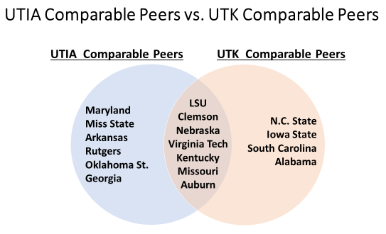

UTIA uses a comparison of 13 schools to comprise its list of ‘Comparable Peers’, while UTK uses a list of 11 schools. There is an overlap of 7 schools between them.

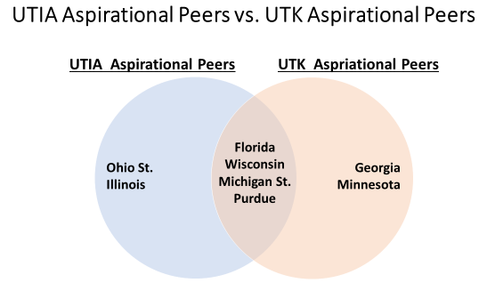
UTIA and UTK both use a comparison of 6 schools to comprise their list of ‘Aspirational Peers’. There is an overlap of 4 schools, while UTIA and UTK both have 2 schools that the other does not.

Results and Findings

AY 2016-2017 Salary Averages and One-Year Salary Increases

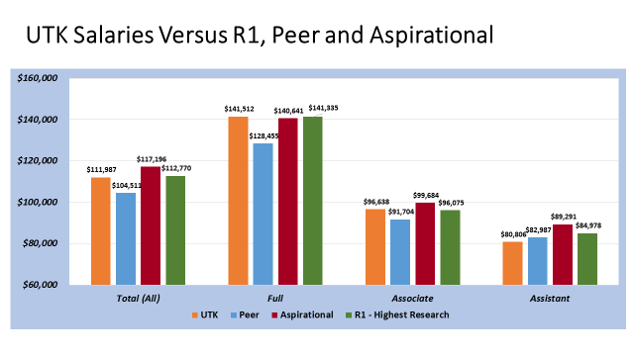

So how does UTK compare?

The chart above compares the total averages of all full-time tenured and tenure-track faculty of UTK faculty (in orange) against three peer groups: Comparable (blue), Aspirational (red) and Research 1 (green). We show the total average for all ranks (1,119 positions), as well as broken down by Full, Associate and Assistant ranks.

When looking at general, overall comparisons, UTK average salaries tend to be higher than the Comparable Peer group, lower than the Aspirational Peer group, and close to the Research 1 Peer group. The main exception to this occurs in the Assistant Professor rank, where the UTK average is below all three peer groups.

- When comparing average faculty salaries across all ranks (including 1,119 positions at UTK), the UTK salary is $111,987, above the $104,511 Comparable Peer average, and below the $117,196 Aspirational Peer average, and close to the $112,770 Research 1 group average.
- For Full Professors, the UTK average salary is $141,500, while the Comparable Peer average is $128,450, the Aspirational Peer average is $140,640 and the Research 1 average is $141,335.
- For Associate Professors, the average salaries are $96,640 (UTK), $91,700 (Comparable), $99,680 (Aspirational) and $96,075 (Research One).
- For Assistant Professors, the average salaries are $80,810 (UTK), $82,990 (Comparable), $89,290 (Aspirational) and $84,978 (Research One).

Note that relative to last year, the change in officially designated peer groups had a significant impact on the average salaries to which UTK salaries are compared. For example, last year the THEC group had average salary across all ranks of $112,474 and the Top-25 group had average salary across all ranks of $119,338. Thus, the comparisons peer groups change led to a reduction of average salary in the peer group of $7,963 (THEC to Comparable Peer) and $2,142 (Top-25 to Aspirational Peer) over a one-year period. If the previous Peer group comparisons had been used, even ignoring the presumed increases in average salaries at the institutions in the previous peer groups, the average salaries for UTK would not have improved nearly as much as indicated by the comparisons to the official designated peer groups.

Change in Salary – Average of UTK compared to Average of R1 institutions:

Salary Increases from 2015/1616 to 2016/17 Academic Year
 | UTK | R1
Overall | 3.4%  ($108,304 to $111,987) | 2.2%  ($110,317 to $112,770)
Full Professor | 2.74%  ($137,736 to $141,512) | 2.47%  ($137,923 to $141,335)
Associate Professor | 3.6%  (93,288 to $96,638) | 2.83%  ($93,433 to $96,075)
Assistant Professor | 2.07%  (%79,169 to $80,806) | 2.68%  ($82,764 to $84,978)

As discussed in last year’s report by the Committee, UTK faculty salaries have had a significant increasing trend over the past decade, leading to a general increase in how UTK average salaries compare to the previous peer comparison groups salary trends over the decade. This general increase relative to R1 peers has continued over the past year except at the Assistant Professor level. It is notable that across UTK, the average percentage salary increase for Associate Professors over the past year was considerably higher than for the other ranks. It is not clear what policy, if any, led to this difference in average salary increases by rank. The Committee has not redone the analysis carried out last year that compares 10-year average changes by unit to R1 or other groups. There is no indication that the results obtained last year, noting the significant differences between Colleges in how salaries have changed over the decade relative to peers, would be different if repeated this year.

Average Salary by College, UTK and UTK vs. Research 1

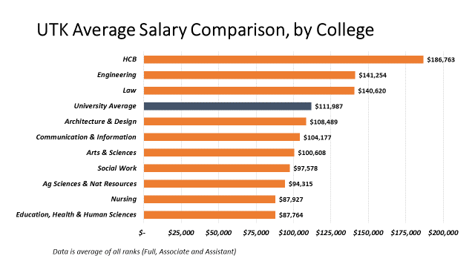

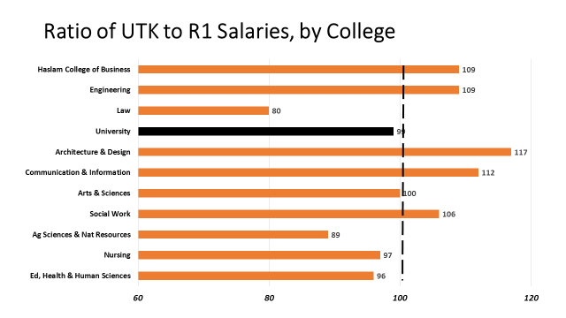

Comparing UTK average salaries at the College level:

The first chart above shows the full average of UTK salaries by College, across all ranks. There is clearly wide variation in average salaries by College. Haslam College of Business far and away has the highest average faculty salaries, at $186,763, with Tickle College of Engineering and Law at lower average salaries more or less tied behind HCB at slightly above $140,000.

Those three Colleges are the only ones with salary above the University (on the whole) average – the other 7 Colleges are below the University average. Nursing and Education, Health and Human Sciences are roughly tied for lowest average salaries. Since there are 283 faculty in the Colleges which have average salaries above the overall University average, representing 25% of the total of 1,119 faculty, about 25% of the faculty are in Colleges with average salaries above the University average. This illustrates an issue with the use of average rather than median salaries, and points out the highly skewed salary distribution across UT Colleges.

Comparing UTK average salaries against average salaries of R1 institutions at the College level:

How do these College averages compare against Research 1 school averages by College? The second chart above takes the ratio of average UTK salary by College and compares it against similar R1 colleges.

Any number above 100 would imply that the UTK average is above the R1 average. For example, Architecture and Design has a score of 117, indicating that its average salary of $108,500 is 17% higher than the Architecture and Design colleges average salary, of $93,000.

Communication has a 112 ratio, indicating that the UTK College of Communication average salary of $104K is 12% higher than the average salary of College of Communication across all R1 schools.
Note that the overall UTK ratio is 99%. The overall UTK faculty salary of $111,987 is a small amount under the overall R1 average of $112,770.

While Law faculty have one of the highest average salaries at UTK at $140K, it has the lowest ratio of 80%, indicating that UTK Law salaries are on average 20% lower than law schools in R1 schools.
The average Social Work faculty salary of $97,578 is well below the University average of $111,987 but above the comparable R1 salaries (6% higher).

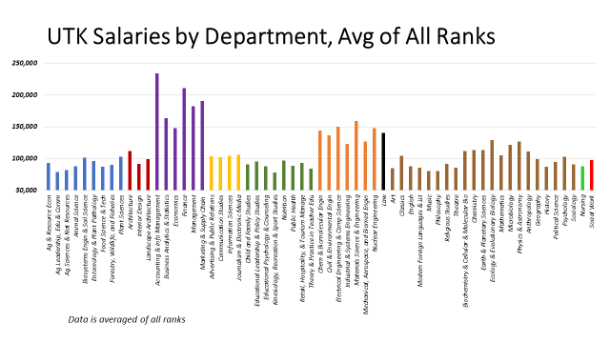

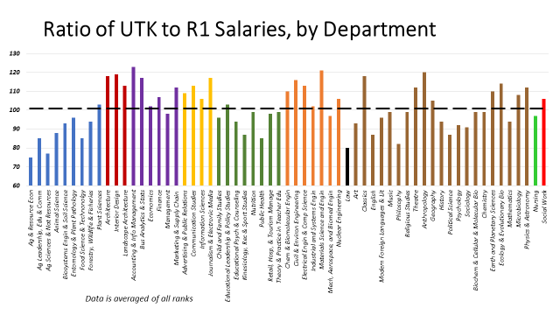

When comparing UTK average salaries at the Department level:

The first above chart illustrates that not only are there considerable differences in average salaries across Colleges, there is considerable variation across departments within Colleges. For A&S, the variation between Departments in average salaries is very high with some units having an average salary 50% above the average salary of the unit with the lowest salary. The variation of average salaries across units within the other Colleges is not quite as high and the overall variation within Colleges is generally much smaller than the variation between Colleges.

When comparing UTK average salaries against R1 institutions at the Department level:

The College of Law has the lowest ratio by college.
But by department, there are 2 in the College of Agricultural Sciences and Natural Resources that are lower – Agricultural and Resource Economics, and Agricultural Sciences and Natural Resources.
The highest UTK – R1 ratio by department is Accounting and Information Management, with a 123 ratio, indicating that it is 23% higher than average R1 salaries in the same department.
- All 3 Architecture departments are above 100
- HBC has 5 out of 6 departments above 100
- Communication has all 4 departments above 100.
- Education, Health and Human sciences has only 1 department above 100, and 7 departments near 100 or lower.
- Engineering has 6 departments above 100, and 1 department below
- Law is below
- Arts and Sciences has 8 departments above 100, 4 very near 100, and 9 departments below
- Nursing is just under 100
- Social work is above, at 106

SUMMARY:
1. The change in peer groups from those used in previous years is of concern due to the great reduction in number of comparison institutions, associated large reduction in number of faculty in the comparison groups, and the biases inherent in making unit/rank comparisons using such limited data. We recommend that for the purposes of faculty salary comparisons, the UTK administration focus on comparisons to the larger group of R1 and not on the “officially designated” peer groups.
2. The overall average salary of UTK faculty has significantly improved over the past decade, relative to R1, and this improvement continued over the past year during which the average UTK salary increased by 3.4% and the overall R1 average salary increased by 2.2%.
3. There is tremendous variation across UTK in how different Colleges and Departments compare to R1 peers. Whether the heterogeneity of progress over the past was planned or unintentional is not clear. While lifting average salaries for every unit relative to peer institutions may have been a goal, in the metrics analyzed here it has not been realized.

Appendix: List of Schools Used for Comparison to UTK

Research University – Very High (63 Total Schools)
Arizona State U | U of Alabama, Birmingham | University of Houston (TX) | University of North Texas
Clemson University | University of Arizona | University of Illinois, Chicago | University of Oklahoma
Colorado State University | University of Arkansas | University of Illinois, Urbana | University of Oregon
Florida State University | University of California, Berkley | University of Iowa | University of South Carolina
Georgia Tech | UC, Davis | University of Kansas | University of South Florida
Iowa State University | UC, Irvine | University of Kentucky | UTK
Kansas State University | UC, LA | University of Louisville | University of Texas, Austin
Louisiana State U | UC, Riverside | University of Maryland | University of Utah
Michigan State University | UC, San Diego | University of Massachusetts | University of Virginia
North Carolina State | UC, Santa Barbara | University of Michigan | University of Wisconsin (Madison)
Ohio State University | University of Colorado, Boulder | University of Minn, Twin Cities | University of Wisconsin (Milwaukee)
Oregon State | University of Connecticut | University of Mississippi | Virginia Commonwealth
Purdue University | University of Delaware | University of Missouri | Virginia Tech
State University of NY, Buffalo | University of Florida | University of Nebraska | Wayne State University
Texas A&M University | University of Georgia | University of New Mexico | West Virginia University
Texas Tech University | University of Hawaii, Manoa | University of North Carolina

Provided in previous data analysis, and this data analysis under a different name: ‘Research 1: Doctoral – Top Research’

Top Public 25 (22 schools)
UC, Santa Barbara | University of Wisconsin (Madison) | University of North Carolina
Michigan State University | Iowa State University | Purdue University
UC, Berkley | Auburn University | North Carolina State
University of Minn, Twin Cities | University of Texas (Austin) | University of Maryland, College Park
UC, Davis | University of Florida | Clemson University
Ohio State University | Texas A & M University | University of Michigan
UC, Los Angeles | University of Georgia | University of Virginia
 | University of Illinois, Urbana/Champaign

Provided in previous data analysis

THEC Peers (16 schools)
University of Florida | North Carolina State University | University of North Carolina, Chapel Hill
University of Georgia | Texas A&M University | University of Texas
Auburn University | University of Kentucky | University of Virginia
Louisiana State University | University of Maryland, College Park | Virginia Polytechnic Institute

Provided in previous data analysis

Comparable Peer Institutions  (11 schools) | Aspirational Peer Institutions  (6 schools)
North Carolina State University | University of Minnesota
Virginia Tech | University of Florida
Auburn University | University of Wisconsin – Madison
Iowa State University | Michigan State University
University of South Carolina | Purdue University
Clemson University | University of Georgia
Louisiana State University
University of Kentucky
University of Missouri
University of Alabama
University of Nebraska

Provided in this data analysis

